How to use your metered dose inhaler (MDI) with large volume spacer device
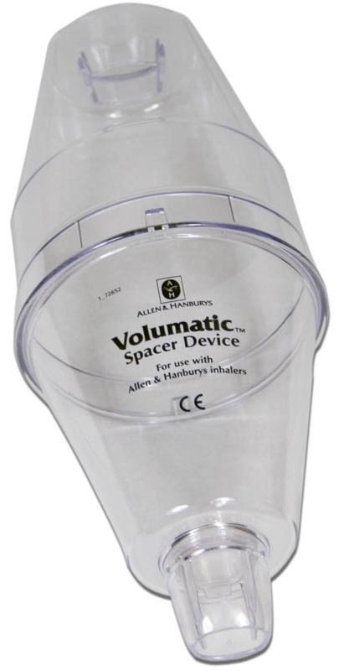
Inhalers are commonly prescribed for patients with asthma and chronic obstructive pulmonary disease (COPD) as they are very effective at delivering the medication straight to the lungs where it is needed.
Using your inhalers correctly is an important part of asthma or COPD treatment. You should be shown how to use inhalers properly by a healthcare professional when they are first prescribed.
You may occasionally experience problems using your inhalers, especially if it has been a while since you were shown the correct technique. This is very common and your healthcare professional can help you improve your inhaler technique.

Why is inhaler technique important?
- It allows the correct dose of medication to reach your lungs.
- It gives you better control of your condition.
Examples of large volume spacer devices | Volumatic

Checklist for metered dose inhaler with large volume spacer use
1 | Stand or sit upright when using your inhaler and spacer.
2 | Firmly fit the two halves of the spacer together.
3 | Remove the inhaler cap.
4 | Hold the inhaler upright and shake four or five times.
5 | Hold the inhaler upright and insert into the spacer.
6 | Breathe out fully.
7 | Place the mouthpiece between your teeth without biting and form a good seal around it with your lips.
8 | Press the top of the inhaler down and take one slow breath in OR if you find it hard to take a deep breath or hold your breath, take five normal breaths in through your mouth.
9 | Hold your breath if you have inhaled using one slow breath. If you have used five normal breaths this is not necessary. Remove the mouthpiece of the spacer from your mouth.
10 | Continue to hold your breath for ten seconds or as long as is comfortable. Breathe out slowly.
11 | If your doctor has told you to take two puffs, wait 30 seconds then repeat steps 4 to 10.
12 | Remove inhaler from spacer and replace the cap straight away to keep out dust.

Common problems
Common mistakes that people make with inhalers and spacers include:
- Not standing or sitting upright, or holding the inhaler upright.
- Not shaking the inhaler before using it and in between doses.
- Not breathing in soon enough after pressing the inhaler so the medication falls to the bottom of the spacer.
- Not remembering to hold your breath if you have inhaled using one steady breath. If you have used five normal breaths this is not necessary.
- Taking several puffs without waiting and not shaking the inhaler in between puffs.
- Not cleaning the spacer correctly. Follow the manufacturer’s instructions.

Useful tips
- Ensure the spacer is the correct one to fit your inhaler.
- If the spacer is in two parts, fit them together.
- If your inhaler contains a corticosteroid rinse your mouth out with water after your dose.
- Spacers are available in different sizes and with face masks if needed.
- Wash your spacer regularly, preferably twice a week. Follow the instructions in the leaflet provided with your spacer. Gently pull the two halves of the spacer apart. Do not take the valve apart. Wash the two halves in warm water which can contain a mild detergent such as washing up liquid or sterilising solution. Rinse thoroughly with clean water.
- Replace spacers every 6 to 12 months.
- Speak to your nurse or pharmacist if you experience problems using your inhaler and spacer device.
- Always read the patient leaflet provided with your inhaler and spacer for any specific instructions.

How did I do?

For video demonstrations on how to use your inhaler visit:

https://player.vimeo.com/video/179464174

Ensure that you have your respiratory condition and inhaler technique reviewed at least annually

